

**GFWC Legislation and Public Policy Quarterly Newsletter 2022-2024**

**Issue No. 5**

**By Esther Gartland, GFWC Great Lakes Region Representative**

**Advocates for Children Week—Children in Foster Care**

“Children are the world’s most valuable resource and its best hope for the future.”

John F. Kennedy, 35th President of the United States

Children are indeed our most valuable resource, and it is up to us to help them become our best hope for the future. During this time leading up to Child Advocate’s Week, Sunday, October 22, to Saturday, October 28, 2023, there are many ways members can help, especially with children in foster care, who are more likely to be at risk.

The following GFWC resolutions all address the need for protecting children in foster care, and include concerns for all children:

**120-010 Child Foster Care**

This resolution urges members to support Legislation and programs that facilitate recruitment, training, and retention of high-quality foster parents and kinship providers.

**120-020 Keeping Children Safe**

This resolution urges members to ensure a safe, educational, and nurturing environment, which is essential to the wellbeing and development of children at home and/or in childcare.

**120-030 Sexual Exploitation of Children**

This resolution urges members to support a national strategy for child exploitation prevention that reaffirms our unwavering commitment to ensure that all children are protected from violence and abuse.

The current crisis with children in foster care is urgent. The statistics vary from state to state, but over all the information is staggering. On a national scale, the Children’s Bureau’s Child Welfare Information Gateway reports more than 391,000 children and youth are in foster care, with mental and behavioral health as the largest unmet needs. The need for foster caregivers is increasing as are the children’s needs in the home.

“Up to 80% of children in foster care have significant mental health issues, compared with approximately 18% to 22% of the general population,” as stated in the information provided by Gateway. The need for foster caregivers has increased because over 50% of children in custody have a guardian with either a substance abuse disorder or mental illness, which can necessitate lengthy treatment. These factors can result in children remaining in foster care longer and limit the availability of new placements in these homes.

Human trafficking, particularly sex trafficking, has become a point of emphasis in the child welfare field due to the high risk of exploitation for children and youth involved with child welfare. Foster children are the number one target for human trafficking. The U.S. Department of Health and Human Services Guide for Child Welfare Agencies states: “Traffickers may specifically target children in (or who have run away from) foster care because of their increased vulnerability, and work to exploit the fact that these children may not have their familial, emotional or basic needs met.” Traffickers promise to meet those needs – at times using psychological manipulation and financial incentives- and then using persuasion, violence, drugs, or physical control to retain and exploit them, the guide states.

The following bills all address needs relating to protecting children and keeping them safe:

* [REPORT Act (S.474)](https://www.congress.gov/bill/118th-congress/senate-bill/474) – Improves NCMEC’s CyberTipline by requiring reporting of child sex trafficking and enticement (grooming). Extends retention period of reported material giving law enforcement more time to conduct investigations.
* [Project Safe Childhood Act (S.1170)](https://www.congress.gov/bill/118th-congress/senate-bill/1170) – Modernizes DOJ’s Project Safe Childhood Program to enhance law enforcement’s response to online child sexual exploitation.

* [EARN IT Act (S.1207)](https://www.congress.gov/bill/118th-congress/senate-bill/1207?q=%7B%22search%22%3A%5B%22s+1207%22%5D%7D&s=4&r=10) –Gives victims of CSAM the right to sue digital platforms that knowingly circulate criminal content; gives victims a chance to restore privacy. Establishes commission to monitor potential online harms. Gives new tools to NCMEC. Replaces "child pornography" with "child sexual abuse material" in federal law.

* [STOP CSAM Act (S.1199)](https://www.congress.gov/bill/118th-congress/senate-bill/1199) – Expands civil remedies for victims of online sexual exploitation. Requires removal of related exploitive visual depictions.
* [Kids Online Safety Act (S.1409)](https://www.congress.gov/bill/118th-congress/senate-bill/1409) – Creates a legally relevant “duty of care” requiring online apps and platforms to center the needs of children. Requires online tools to safeguard children automatically. Creates more transparency by allowing researchers access to data regarding algorithms for example.

The Legislative Action Center allows members to read and track a bill, plus see how their elected officials voted on the bill when it reaches the floor.

Additionally, a very important way to advocate for all children is by requesting a Proclamation. Work with your city, county, or state to have the fourth week in October recognized as Advocates for Children Week. There is a sample proclamation under Advocates for Children in the GFWC Manual and in the Member Portal’s Digital Library under “A”.

Once proclamations are received, celebrate the achievement by posting photos to social media with the #GFWCAdvocacy. That will score you points on the Scavenger Hunt.

**National Day of Service**

Thank you to everyone that told Congress to address food insecurity and fully fund the programs that combat hunger. Members send 2,193 messages via the Legislative Action Center. The top five states were Florida, North Carolina, California, Illinios, and Georgia. You can still take action on this alert by going to

<https://www.votervoice.net/GFWC/Campaigns/107882/Respond>

It was wonderful to see so many clubs obtain Proclamations recognizing the General Federation of Women’s Clubs National Day of Service. Receiving a Proclamation and meeting with an elected official are items on the GFWC Scavenger Hunt. Wearing their GFWC name tags and or club attire and using the #GFWCAdvocacy scores bonus points on the Scavenger Hunt. Here are just a few of the photos found on Facebook.

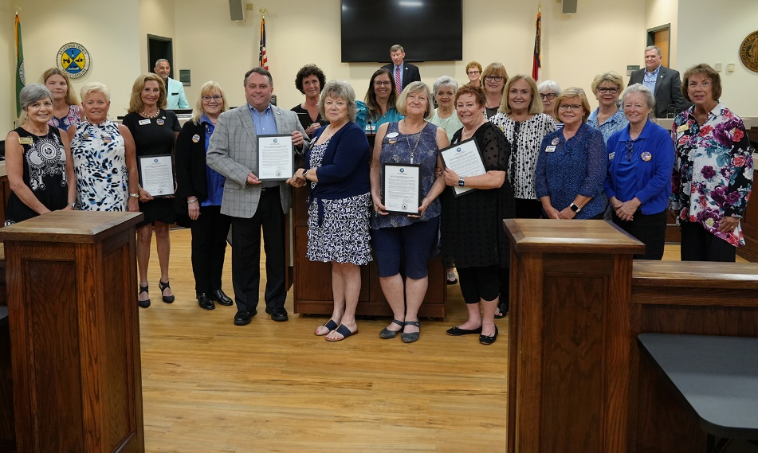

Five Clubs in Brunswick County, NC obtained proclamations from their Board of Commissions: GFWC Cape Fear Woman's Club, GFWC of Holden Beach, GFWC-South Brunswick Islands, Shallotte Junior Woman's Club, and Southport Woman's Club.

The Junior Women’s Club of Barnesville (OH) received its Proclamation for Mayor Dale Bunting.

**GFWC LEGISLATION AND PUBLIC POLICY COMMITTEE**

The members of the GFWC Legislation and Public Policy Committee are here for you. Please contact the member in your region with any questions you may have. We would love to speak to your state federation or club, in person or via Zoom.

Juliet Casper (SC), Chair Southern [jcasper9200@gmail.com](mailto:jcasper9200@gmail.com) c. 843-446-8479

Esther Gartland (OH) Great Lakes [gartlanddj@aol.com](mailto:gartlanddj@aol.com) c. 330-883-8449

Debbie Fiore (CT) New England [debfioregfwc@cox.net](mailto:debfioregfwc@cox.net) c. 860-882-9553

Carolyn Forbes (DE) Middle Atlantic [mrschefdjf@aol.com](mailto:mrschefdjf@aol.com) c. 302-222-6468

Kathy Huggins (NE) Mississippi Valley [khuggins555@gmail.com](mailto:khuggins555@gmail.com) c. 402-517-6196

Sally Harper (NM) South Central [saharper@nmsu.edu](mailto:saharper@nmsu.edu) c. 575-644-7328

Jennifer Jobe (NC) Southeastern [jenniferwjobe@gmail.com](mailto:jenniferwjobe@gmail.com) c. 336-251-2094

Joyce DeCunzo (MT) Western States [joycedecunzo2018@gmail.com](mailto:joycedecunzo2018@gmail.com) c. 406-439-0076

**TOGETHER We Advocate For Those In Need**