GFWC Civic Engagement and Outreach
  - Volume 1/ Issue 5 FALL/WINTER ISSUE
Sharon Oliphant
Chairman 2022-2024
871 NW 251st Drive
Newberry, Florida 32669
727-424-3835
Solip561@aol.com
Welcome to the GFWC Civic Engagement and Outreach CSP! I am excited to serve as your chairman for the 2022-2024 Administration. My goal is to provide information for you to be able to pass on in your state and assist you in this area. Please feel free to share this newsletter with clubs in your state.

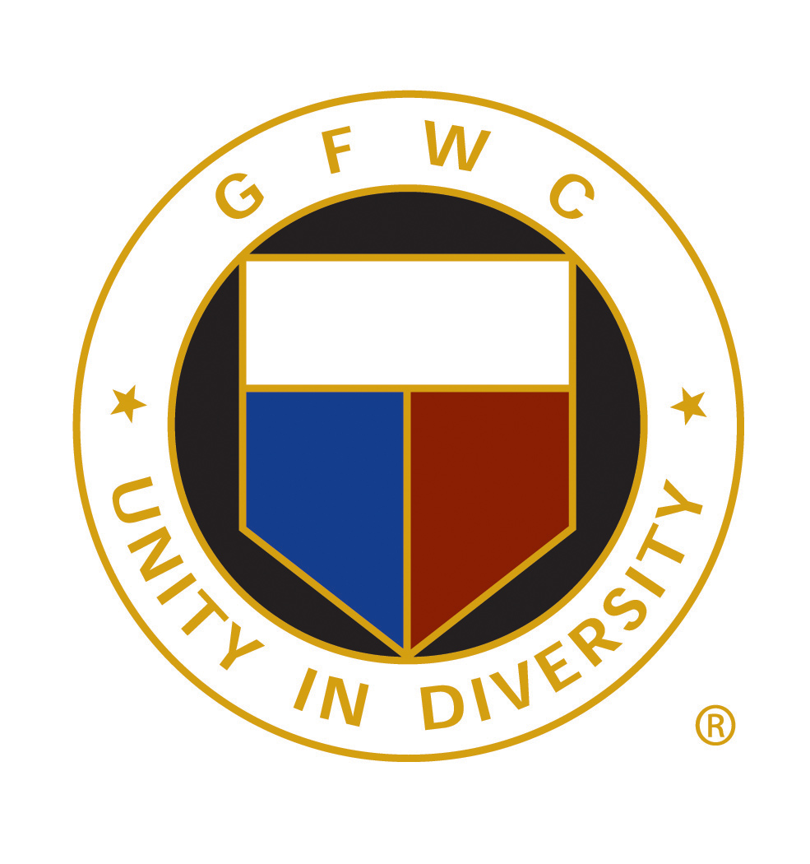
www.GFWC.org

Community Connection
GFWC members are reminded that each of us is a part of a larger society and is responsible for addressing issues of public concern. We advocate because there is a need; we volunteer because we are needed. Our focus is on our community and looking for better ways to make an impact.

Understanding the Civic Engagement and Outreach Community Service Program
Civic Engagement and Outreach are highlighted and encouraged. Many areas are emphasized and identified; however, your projects and programs are most important in reaching out and preparing for community outreach and impact. You will make the difference.
  - Essential Workers
  - Citizenship
  - Crime Prevention
  - Safety and Disaster Preparedness
  - Needy, Hungry and Homeless
  - Military Personal
  - Veterans
  - Women Veteran Support and Outreach

German Chocolate Pumpkin Muffins (easy!)
I am not much of a pumpkin fan. But chocolate makes everything better for me.
This Photo by Unknown Author is licensed under CC BY-SA-NC
Ingredients
1 package (15-ounce size) German Chocolate Cake Mix or can use Spice Cake Mix
2 cups pureed pumpkin
½ cup of milk chocolate chips (optional)
½ cup of chopped pecans (optional)
½ cup coconut flakes (optional)
HEAT OVEN TO 400 F
Steps
Combine all ingredients and spoon into 18 count muffin tins (I use paper liners) spray with cooking spray.
Bake at 400 degrees for 20 minutes.

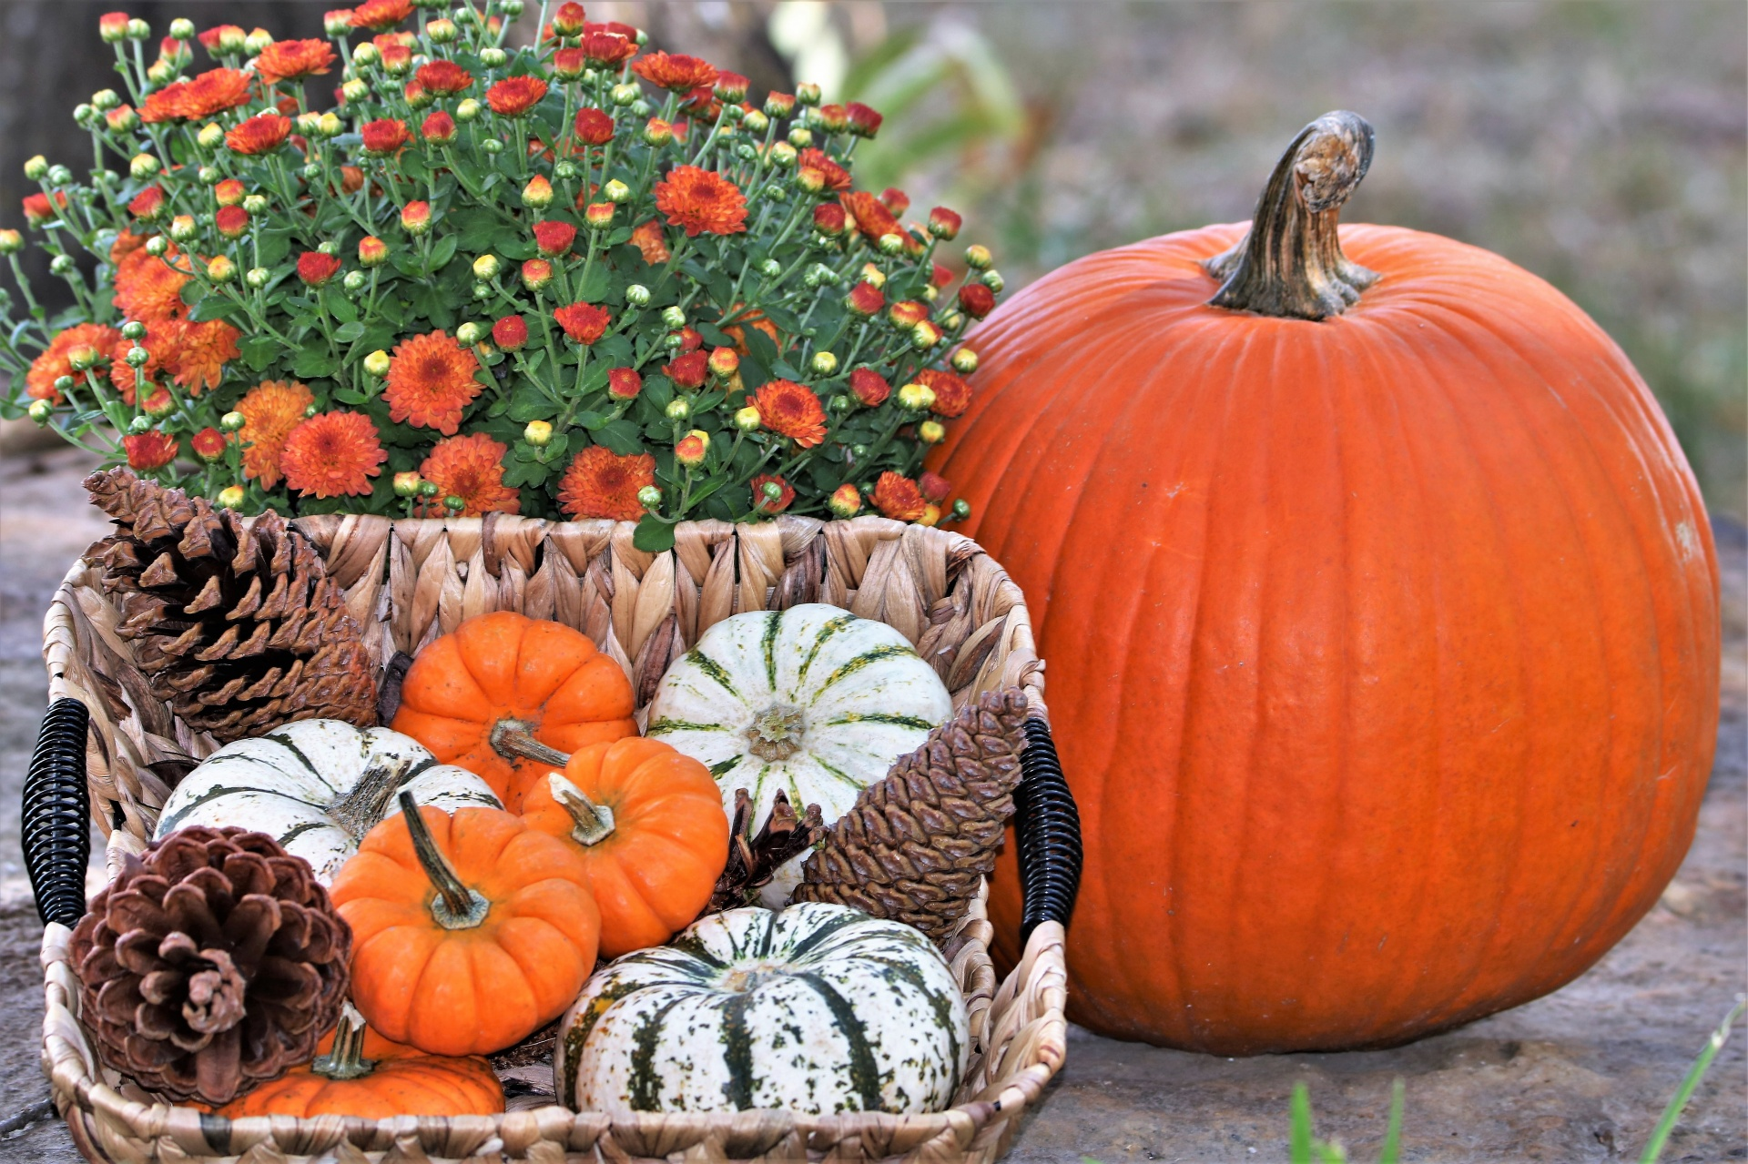
UPCOMING DATES AND EVENTS September/October/November
September Events
Hunger Action Month
National Eye Health Week September 18-24
Childhood Cancer Awareness Month
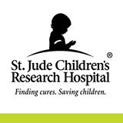
October Events
Breast Cancer Awareness Month
National Book Month
ADHD Awareness Month
Depression Awareness Month
Domestic Violence Awareness Month
National Downs Syndrome Month
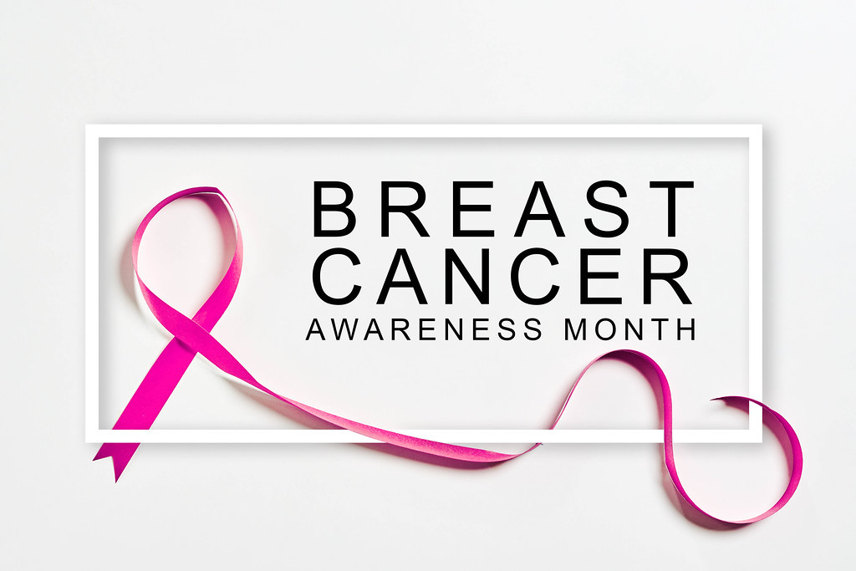
November Events
Diabetes Awareness Month
National Homeless Youth Awareness Month
Native American Heritage Month
GIVING TUESDAY (Tuesday after Thanksgiving)
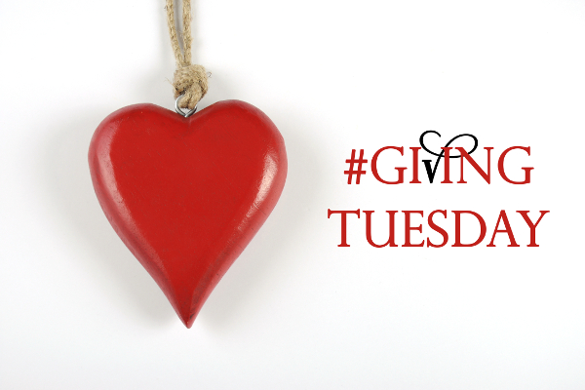
Fall is coming……Winter is next
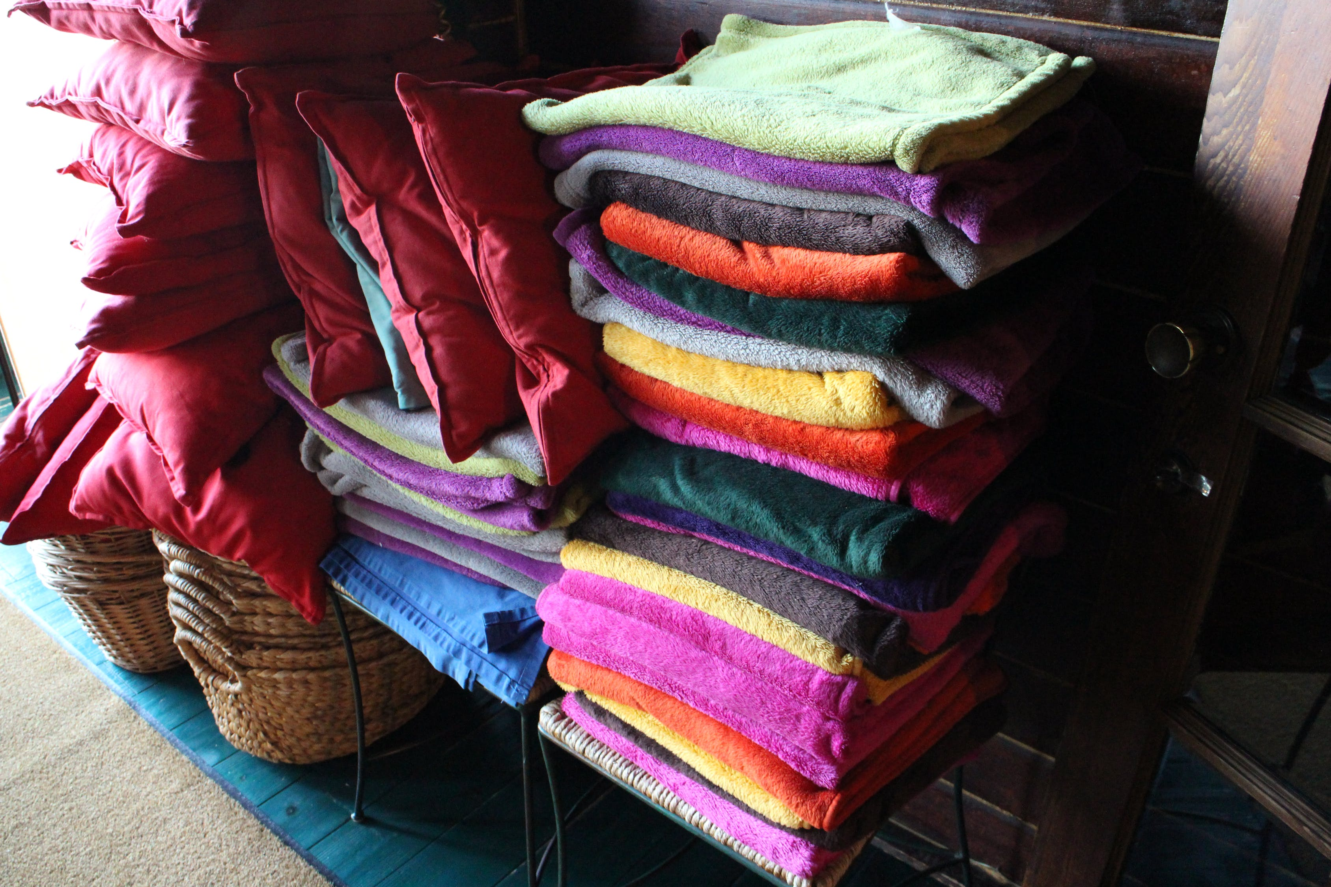
Here in Florida, we do not have that change of seasons. We are usually hot, warm, and a bit cooler, but for those of you in the areas of cooler weather, don’t forget the shelters that will have more people showing up with needs. I love garage sales and going to thrift stores. They are currently overloaded with blankets, sleeping bags, coats, and jackets. Make it a fun day. Meet for breakfast; everyone has in their pocket $20 and do a day of winter shopping for those in need. You will be amazed at what $20 can do! Also, towels and sheets! The shelters have animals that will need to keep warm, too! Those that have stains or rips don’t matter to a shelter animal. And, reach out to the VA, the shelters, and animal rescues; they have wish lists. Make it a fun day and challenge members to see who the thrifty shopper can be!
Most purchased with their $20 could win a trophy, certificate, or a crown!

Hunger in America - Food Insecurity
Thank you to everyone who has signed up and will participate in the GFWC National Day of Service. Just think, if each of us donated 1-2 cans of food, that could be life-changing for our food banks, church shelters, local veteran’s centers, and safe places. We can continue to make a difference through awareness. Awareness brings funding and commitment. One out of 10,000 female individuals is homeless! The average age is 35, has children, and has experienced homelessness more than once in their lifetime. 80% of these women have experienced domestic violence. Your state presidents will send in a report to GFWC of our activities and events. These same totals will be reported in this CSP.
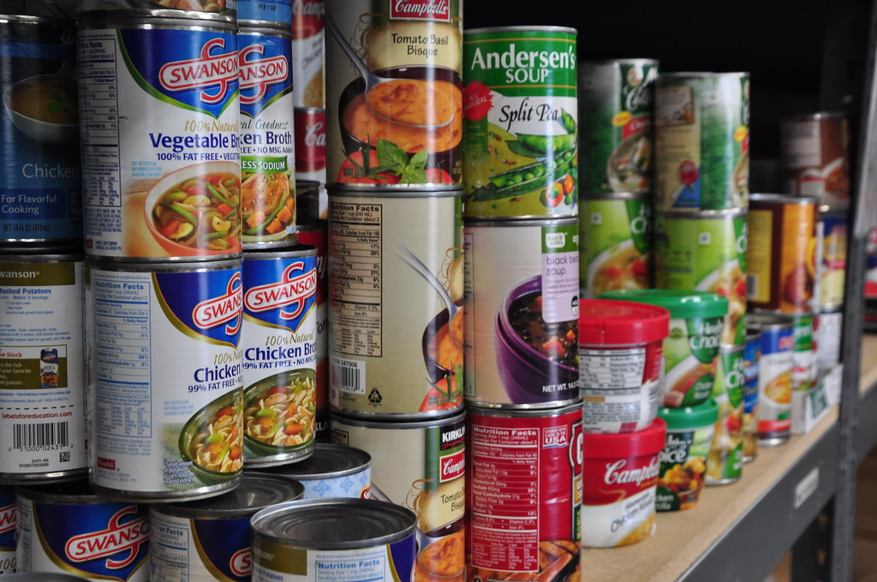

Military Recognitions
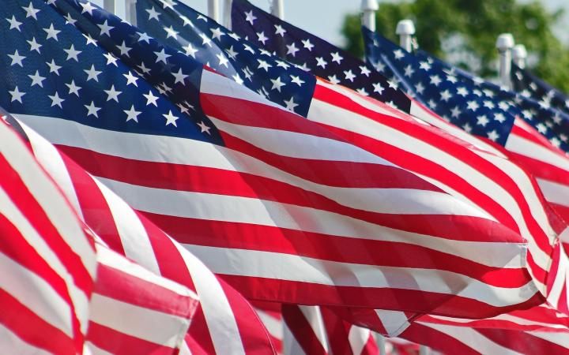

Gold Star Mother’s and Family Day
September 24
A day set aside to honor the families of our nation’s fallen service members, initially formed in 1928 for American mothers who lost sons or daughters in service. The name came from the custom of families hanging a banner called a service flag in the windows of their homes. The service flag had a star for each family member in the Armed Forces. Living servicemen are represented by a Blue Star. A Gold Star represents those lost in combat.
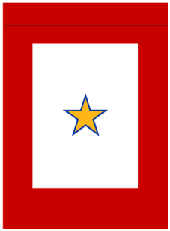
Veteran’s Day, Memorial Day and Armed Forces Day
are the 3 noted holidays for Veterans.
Remember the “Tie a Yellow Ribbon Around the Ole Oak Tree” song by Tony Orlando and Dawn? Yellow ribbons are commonly used to show support for active-duty military troops. This was common when soldiers were coming home, retiring, or being celebrated. Do you have a soldier in your community coming home? Why not decorate your community and celebrate their service and commitment to our freedom?

Veteran’s Day November 11, 2023
Veteran’s Day is observed annually on November 11. This day is recognized worldwide to celebrate military veterans who are or have served in the Armed Forces. Armistice Day was first recognized in 1919 by Woodrow Wilson, and the name was changed to Veteran’s Day after WWII and the Korean War.

Wreaths Across America-Save the Date December 16
The deadline for Wreaths Across America is coming soon. For a $17 sponsorship, an American Hero will have a wreath placed on their graves. To remember our fallen U.S. Veterans and honor those who served. Also, to teach our children the value of freedom. More than two million volunteers nationwide will participate in the day of honor. Go to the website to see if a cemetery in your area is participating. If not, sponsor one!
www.wreathsacrossamerica.org
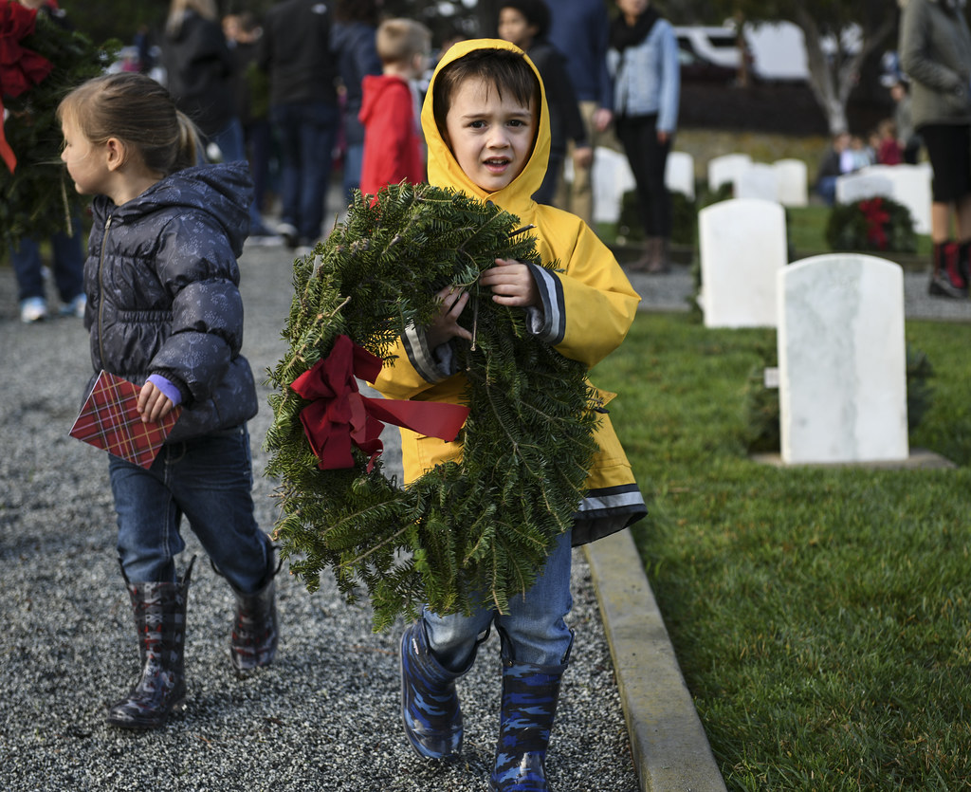

United States Coast Guard-NEW Community Initiative
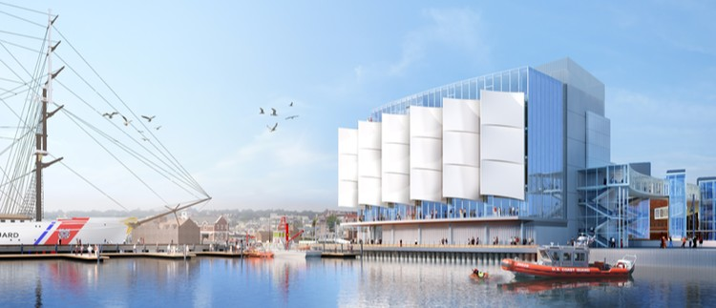

GFWC’s new Civic Engagement and Outreach initiative is asking us to build a museum!
By: Sharon Oliphant, Civic Engagement and Outreach Chairman &
Jennifer Hawkins, GFWC Florida Clubwoman
This is not just any museum; our efforts will be to assist in the fundraising efforts for constructing the United States Coast Guard Museum in New London, Connecticut.
The United States Coast Guard has existed since 1790, starting as the Revenue Cutter Service for the newly created United States. Since that time, women have been an integral part of the Coast Guard’s Mission, beginning as assistant lighthouse keepers during the Revolutionary War while their husbands were away fighting. Today, Admiral Linda Fagan serves as the Coast Guard Commandant, the highest-ranking officer of the Coast Guard, and the first woman to lead a branch of the United States military.
The United States Coast Guard has led the way with women being placed in leadership roles. The Coast Guard was the first to grant women an opportunity to attend Officer Candidacy School in the 1970’s. The United States Coast Guard Academy female enrollment stands at 43% for the class of 2026, nearly 20% higher than the other three service academies.

Nearly everyone’s lives have been directly or indirectly affected by the Coast Guard. Ninety percent of all imported goods to our country arrive under Coast Guard patrol, navigation aids placed in the Mississippi River and Missouri Rivers help bring commodities from the farmlands of America, and taconite from Minnesota and Michigan is shepherded through the Great Lakes with Coast Guard assistance. The Coast Guard protects the shrimp, fish, and crab you have for dinner.
Currently, the Museum Foundation has raised $142 Million. Our long history of fulfilling needs in our community and our Nation provides us with a unique opportunity to help the Coast Guard Museum Foundation accomplish this monumental undertaking. Let us honor the women who served in the past, those who serve now, and those who will serve in the future with values, honor, respect, and devotion to duty with our fundraising skills and push the United States Coast Guard Museum across the finish line.
MORE INFORMATION COMING SOON
National Coast Guard Museum (uscg.mil)

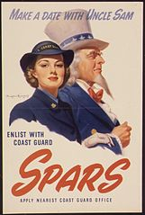

GFWC Clubwomen served directly starting in WWII as uniformed clerical workers at Coast Guard Headquarters in Washington, D.C. During WWII, the Coast Guard recruited women into their women’s reserve known as SPARS
(Semper Paratus-Always Ready)
Essential Workers and the Holiday Season

Our community intuitive is still focusing on our essential workers. Those who work on holidays, during weather emergencies, and other agencies are open 24 hours. As we start to see life creep back to normal, we still have many essential workers we need to thank! Maybe something to brighten up their workspace. A sign in your yard saying, “thank you,” a basket on your porch for the delivery driver, or a small token for your post office worker ($20 limit). Some new fun socks for the nurses and doctors! Hand and body lotion for the teachers, bank tellers, and restaurant workers. A gift card for the recycler or waste management drivers. Provide a lunch in the breakroom. Donate a few fruit baskets. Offer a day of gift cards. Decorate a work floor for the holidays. A few boxes of granola bars and pretzels! Maybe some apple cider and hot cocoa.

It is a busy time, and things get hectic. Just think of one gesture of gratefulness that can make someone’s day much better!
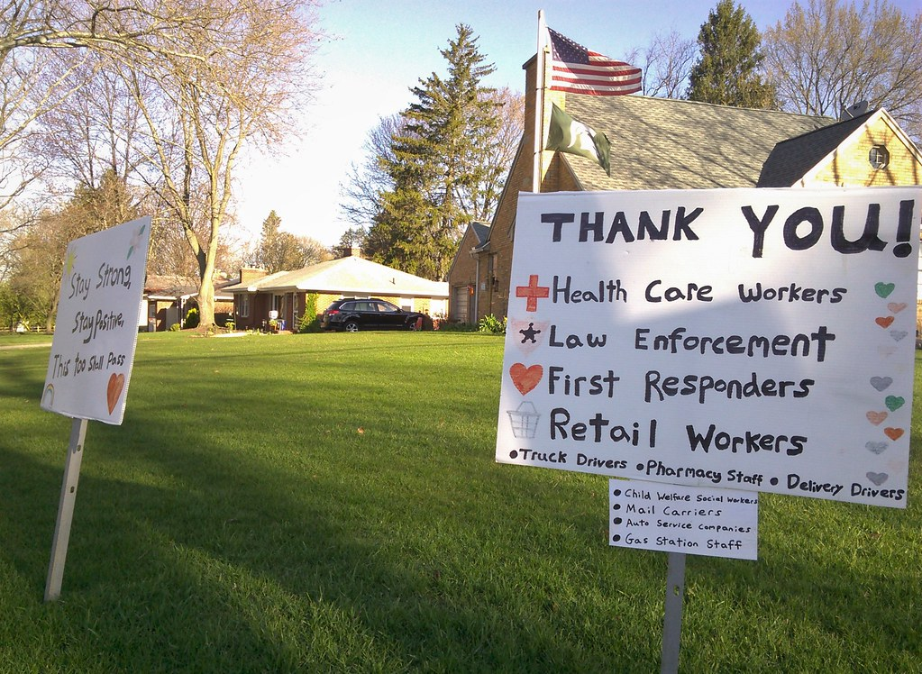

A few top projects reported in 2022
One club collected 7,800 boxes of Jello for the food pantry.
One club collected and filled 240 stockings for soldiers.
One club clipped coupons for Fisher House that totaled $51,320.
One club delivered 195 bears to the Fire Station and Police Station for young children.
One Club donated 800 signed holiday cards to the American Legion.
One club donated 2,275 pounds of food to the local food bank.
One club partnered with the DAR and purchased 999 wreaths for Wreaths Across America.
One club hid over 3,000 eggs for the Annual Easter Egg Hunt.
Volunteerism has a value of over $184 billion dollars. Volunteers are priceless, but to another organization, your value helps them with their budgets!
